Multidimensional Approach of Spectra and Morphology of Oral Squamous Cell Carcinoma (OSCC)

Introduction and Project Idea
Among the many diseases affecting humans, cancer is a major public health challenge, being the second most common cause of death after cardio-vascular diseases. The intrinsic heterogeneity of cancer, comprising at least 200 different types of neoplastic diseases affecting a variety of organs, implies corresponding heterogeneity in the risk factors, in the biological and clinical courses of the disease and in the required treatments. Among malignant diseases the oral squamous cell carcinoma (OSCC) is the eight most common cancer and has an annual incidence of approximately 1 in 300,000 persons world-wide and is the sixth most common cancer worldwide (1, 2). In Austria, each year ~1100 patients develop head and neck malignancies (see also Fig. 1) (http://www.statistik.at/).

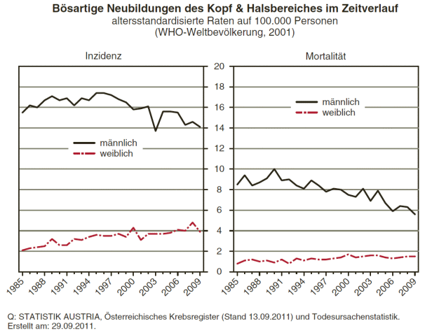
Fig. 1 Austrian Cancer Registry (27.08.2009) and cause of death statistic origin: STATISTIK AUSTRIA.

Currently, men are affected twice as often as women, but a steady increase of new cases can be observed among women in recent years (3). The use of alcohol, tobacco or betel quid independently represents a risk for the development of OSCC (4, 5). Moreover recent investigations demonstrated the relationship of human papilloma virus and OSCC (6). OSCC tend to spread locally and regionally to lymph nodes in the neck and more than 50% of neck lymph nodes show metastases at the time of diagnosis (7). Early detection of OSCC is thus the most efficient way to reduce associated mortality. However, there has been scarcely any progress in the past 20 years, leaving most patients diagnosed at advanced stage of the disease. Despite optimization of treatment modalities, including surgery in combination with radio- and chemotherapy, the prognosis is poor with a five-year survival rate of slightly above 50% which hardly improved over the past 30 years (8). The 5-year survival is dependent on the extent of the neoplasm at first diagnosis. In this regard, early detection of such neoplasms is of particular importance.
In contrast to other tumour entities like prostate cancer, pancreas cancer or others there is currently no reliable biomarker to detect early cancer formation in OSCC. Biomarkers that have been detected in the cancer tissue in the past are mainly correlated with the prognosis of the cancer and partially reflect the efficiency of possible treatment options (9-12).
Therefore the diagnosis is based on clinical observation and imaging techniques. Especially diagnostic imaging plays an essential role in the clinical evaluation and management of patients with OSCC. Various imaging technologies have been developed to complement the clinical and pathological examination of the original staging process of cancers (13). These may include magnetic resonance imaging (MRI) (14), computed tomography (CT) (15), ultrasonography (US) (16), positron emission tomography (PET) scan (17), and others.
However, non-invasive radiological methods do not reflect an overview of the biochemical composition in order to correctly classify tumourous tissue or even detect suspicious areas. Thus, the ideal imaging technique does not exist, but nevertheless all methods mentioned above have distinct advantages for specific applications in cancer diagnosis (18). The only reliable way to confirm the diagnosis of OSCC is the histopathological evaluation of tissue specimen using light microscopy (LM). This requires an invasive treatment to gain a tissue specimen. Moreover, histopathological characterization with LM is a time consuming and sometimes subjective technique, with inter- and intra-observer discrepancy. Therefore, novel diagnostic and prognostic biomarkers are essential for the clinical management in the individual patient. Also in clinical routine there is a need for a non-invasive screening method to distinguish benign from malign transformation.

To summarize the clinical and pathological diagnosis of cancer is complex and demands a range of bio-analytical techniques for its investigation. The lack of reliable tools for a rapid, non-invasive diagnosis underscores the need for new techniques such as mitochondrial DNA (mtDNA) sequencing, Matrix Assisted Laser Desorption/Ionization (MALDI) Imaging Mass Spectrometry (IMS) (19) and Fourier Transform Infrared (FTIR) microscopic imaging (20-23).

